**LAB 4**

**1:Write a program to create student class with data members rollno, marks1,mark2,mark3.**

**Accept data (acceptInfo()) and display using display member function.**

**Also display total,percentage and grade.**

#include<iostream>

using namespace std;

class Student

{

private:

double m1,m2,m3,T,P;

int rollno;

public:

void acceptinfo()

{

cout<<"Enter Roll no -";

cin>>rollno;

cout<<"Mark 1 -";

cin>>m1;

cout<<"Mark 2 - ";

cin>>m2;

cout<<"Mark 3 - ";

cin>>m3;

T=m1+m2+m3;

P=(T/300.0)*100.0;

}

void diplay()

{

cout<<"\nTotal Marks:"<<T<<"\nPercentage:"<<P<<endl;

if(P>=91)

cout<<"Grade:A";

else if(P<=90&&P>80)

cout<<"Grade:B";

else if(P<=80&&P>70)

cout<<"Grade:C";

else if(P<=70&&P>61)

cout<<"Grade:D";

else

cout<<"Grade:E";

}

};

int main()

{

Student s1;

s1.acceptinfo();

s1.diplay();

return 0;

}

**OUTPUT**

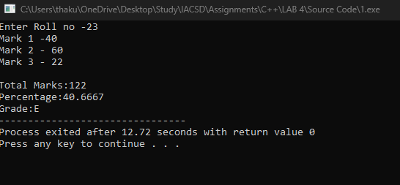

**2. Create a class Person with data members as name, age, city. Write getters and setters for all the data members. Also add the display function. Create Default and Parameterized constructors. Create the object of this class in main method and invoke all the methods in that class.**

#include<iostream>

using namespace std;

class Person{

private:

string name,city;

int age;

public:

Person()

{

name="HK";

city="Raipur";

age=22;

}

Person(string name,string city,int age)

{

this->name=name;

this->city=city;

this->age=age;

}

void display_all()

{

cout<<"Name-"<<name<<endl;

cout<<"City-"<<city<<endl;

cout<<"Age-"<<age<<endl;

}

string get_name()

{

return name;

}

string get_city()

{

return city;

}

int get_age()

{

return age;

}

void set_name(string name)

{

this->name=name;

}

void set_city(string city)

{

this->city=city;

}

void set_age(int age)

{

this->age=age;

}

};

int main()

{

string name,city;

int age,ch;

cout<<"\nEnter Name:";

cin>>name;

cout<<"\nEnter City:";

cin>>city;

cout<<"\nEnter Age:";

cin>>age;

Person p1(name,city,age);

cout<<"\n1.Display All 2.Get Name 3.Get City 4.Get Age 5.Set Name 6.Set City 7.Set Age 8.Exit "<<endl;

do

{

cout<<"\nEnter Choice: ";

cin>>ch;

switch(ch)

{

case 1:

p1.display_all();

break;

case 2:

cout<<p1.get_name();

break;

case 3:

cout<<p1.get_city();

break;

case 4:

cout<<p1.get_age();

break;

case 5:

cout<<"Enter New Name-";

cin>>name;

p1.set_name(name);

break;

case 6:

cout<<"Enter New City-";

cin>>city;

p1.set_city(city);

break;

case 7:

cout<<"Enter New Age-";

cin>>age;

p1.set_age(age);

break;

default:

cout<<"Enter Valid Choice";

}

}while(ch!=8);

return 0;

}

**OUTPUT**

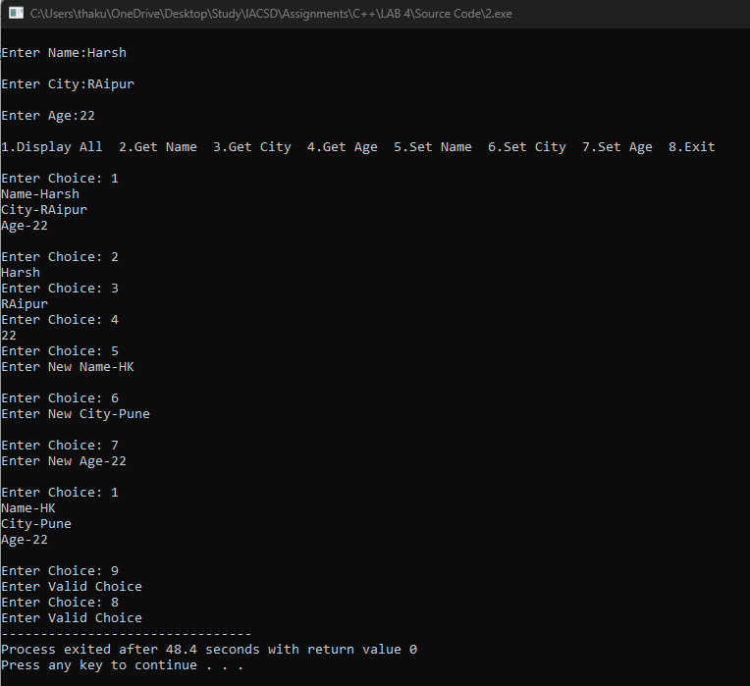

**3. Create a class Date with data members as dd, mm, yy. Write getters and setters for all the data members. Also add the display function. Create Default and Parameterized constructors. Create the object of this class in main method and invoke all the methods in that class.**

#include<iostream>

using namespace std;

class date

{

private:

int d,m,y;

public:

date()

{

d=06;

m=03;

y=2001;

cout<<"Date :"<<d<<"/"<<m<<"/"<<y;

}

date(int d,int m,int y)

{

this->d=d;

this->m=m;

this->y=y;

}

void display()

{

cout<<d<<"/"<<m<<"/"<<y;

}

int get_day()

{

return d;

}

int get_month()

{

return m;

}

int get_year()

{

return y;

}

void set_day(int d)

{

this->d=d;

}

void set_month(int m)

{

this->m=m;

}

void set_year(int y)

{

this->y=y;

}

};

int main()

{

int d,m,y,ch;

cout<<"Enter Day - ";

cin>>d;

cout<<"\nEnter Month - ";

cin>>m;

cout<<"\nEnter Year - ";

cin>>y;

date d1(d,m,y);

cout<<"\n1. Display 2.Get Day 3.Get Month 4.Get Year 5.Set Day 6.Set Month 7.Set Year 8.Exit"<<endl;

do

{

cout<<"\nEnter Choice:";

cin>>ch;

switch(ch)

{

case 1:

d1.display();

break;

case 2:

cout<<d1.get_day();

break;

case 3:

cout<<d1.get_month();

break;

case 4:

cout<<d1.get_year();

break;

case 5:

cout<<"Enter New Date:";

cin>>d;

d1.set_day(d);

break;

case 6:

cout<<"Enter New Month:";

cin>>m;

d1.set_month(m);

break;

case 7:

cout<<"Enter New Year:";

cin>>y;

d1.set_year(y);

break;

default:

cout<<"Invalid Choice!!!";

}

}while(ch!=8);

return 0;

}

**OUTPUT**

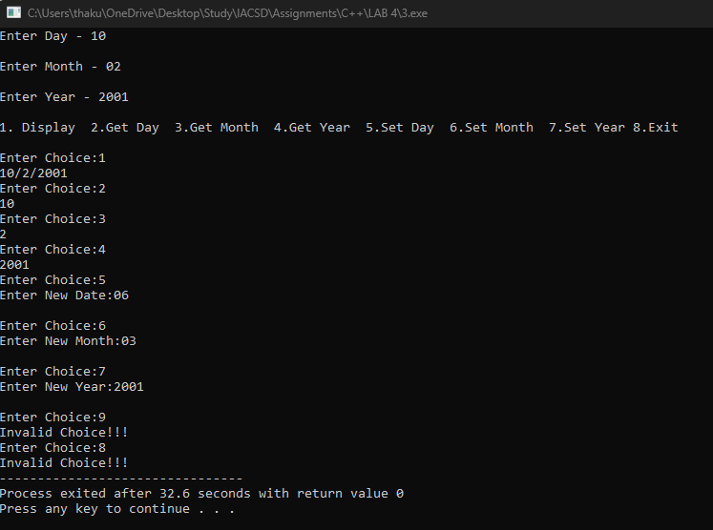

**4. Create a class Book with data members as bname,id,author,price. Write getters and setters for all the data members. Also add the display function. Create Default and Parameterized constructors. Create the object of this class in main method and invoke all the methods in that class.**

#include<iostream>

using namespace std;

class book

{

private:

int id;

double price;

string bname,author;

public:

book()

{

bname="Mahabharat";

id=108;

price=000.00;

author="Krishna";

}

book(string bname, double price, string author,int id)

{

this->id=id;

this->price=price;

this->author=author;

this->bname=bname;

}

void display()

{

cout<<"Book Name - "<<bname<<"\nPrice - "<<price<<"\nAuthor - "<<author<<"\nID - "<<id<<endl;

}

int get_id()

{

return id;

}

int get_price()

{

return price;

}

string get_author()

{

return author;

}

string get_book_name()

{

return bname;

}

void set_price(int price)

{

this->price=price;

}

};

int main()

{

int id,ch;

double price;

string bname,author;

cout<<"Enter ID - ";

cin>>id;

cout<<"\nEnter Book Name - ";

cin>>bname;

cout<<"\nEnter Author - ";

cin>>author;

cout<<"\nEnter Price - ";

cin>>price;

book b1(bname,price,author,id);

cout<<"\n1. Display 2.Get ID 3.Get Price 4.Get Auhtor Name 5.Get Book Name 6.Set Price 7.Exit "<<endl;

do

{

cout<<"\nEnter choice - ";

cin>>ch;

switch(ch)

{

case 1:

b1.display();

break;

case 2:

cout<<b1.get_id();

break;

case 3:

cout<<b1.get_price();

break;

case 4:

cout<<b1.get_author();

break;

case 5:

cout<<b1.get_book_name();

break;

case 6:

cout<<"Enter New Price - ";

cin>>price;

b1.set_price(price);

break;

default:

cout<<"Enter a valid choice!!!";

}

}while(ch!=7);

}

**OUTPUT**

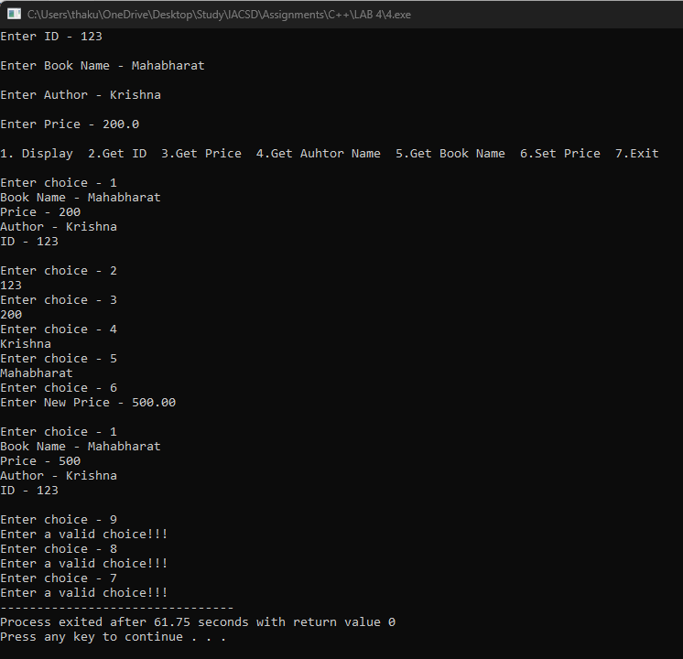

**5. Create a class Point with data members as x,y. Create Default and Parameterized constructors. Write getters and setters for all the data members. Also add the display function. Create the object of this class in main method and invoke all the methods in that class.**

#include<iostream>

using namespace std;

class Point

{

private:

int x,y;

public:

point()

{

x=10;

y=20;

}

Point(int x,int y)

{

this->x=x;

this->y=y;

}

void display()

{

cout<<"\nx coordinate = "<<x<<"\ny coordinate = "<<y<<"\n("<<x<<","<<y<<")"<<endl;

}

int get_x()

{

return x;

}

int get_y()

{

return y;

}

void set_x(int x)

{

this->x=x;

}

void set_y(int y)

{

this->y=y;

}

};

int main()

{

int x,y,ch;

cout<<"Enter x coordinate - ";

cin>>x;

cout<<"\nEnter y coordinate - ";

cin>>y;

Point p1(x,y);

cout<<"\n1.Display 2.Get x coordinate 3.Get y coordinate 4.Set x coordinate 5.Set y coordinate 6.Exit"<<endl;

do

{

cout<<"\nEnter Choice - ";

cin>>ch;

switch(ch)

{

case 1:

p1.display();

break;

case 2:

cout<<p1.get_x();

break;

case 3:

cout<<p1.get_y();

case 4:

cout<<"\nEnter New Value of x - ";

cin>>x;

p1.set_x(x);

break;

case 5:

cout<<"\nEnter New Value of y - ";

cin>>y;

p1.set_y(y);

break;

default:

cout<<"Enter a valid choice!!!";

}

}while(ch!=6);

return 0;

}

**OUTPUT**

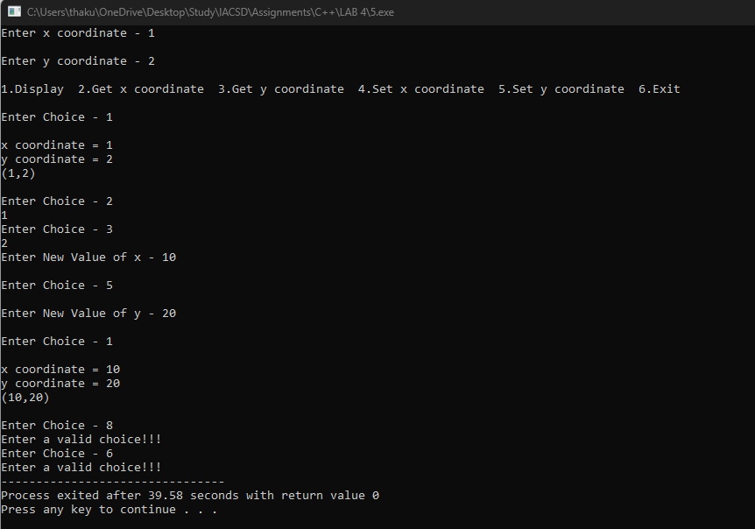

**6. Create a class ComplexNumber with data members real, imaginary. Create Default and Parameterized constructors.**

**Write getters and setters for all the data members.**

**Also add the display function. Create the object of this class in main method and invoke all the methods in that class.**

#include<iostream>

using namespace std;

class Imag

{

private:

int a,b;

public:

Imag() //Default Counstructor

{

a=10;

b=20;

}

Imag(int a,int b) //Parametrised Constructor

{

this->a=a;

this->b=b;

}

void Display()

{

cout<<"Real Part - "<<a<<"\nImaginary Part - "<<b<<endl;

}

int get_real()

{

return a;

}

int get_imag()

{

return b;

}

void set_real(int a)

{

this->a=a;

}

void set_imag(int b)

{

this->b=b;

}

};

int main()

{

int a,b,ch;

cout<<"Enter real part - ";

cin>>a;

cout<<"\nEnter imaginary part - ";

cin>>b;

Imag i(a,b);

cout<<"\n1.Display 2.Get Real Part 3.Get Imaginary Part 4.Set Real Part 5.Set Imaginary Part 6.Exit "<<endl;

do

{

cout<<"\nEnter choice - ";

cin>>ch;

switch(ch)

{

case 1:

i.Display();

break;

case 2:

cout<<i.get_real();

break;

case 3:

cout<<i.get_imag();

break;

case 4:

cout<<"Enter a real value - ";

cin>>a;

i.set_real(a);

break;

case 5:

cout<<"Enter a real value - ";

cin>>b;

i.set_imag(b);

break;

default:

cout<<"Enter a valid choice!!!";

}

}while(ch!=6);

return 0;

}

**OUTPUT**

